Gymtastiks Summer Camps 2025
$150/week or $425/July or August (3 weeks each) before June 15th $165/week on June 16th
½ week (choose mornings 9am - 12 pm or afternoons 1pm -4pm $90/week before June 15th $100/week on June 16th
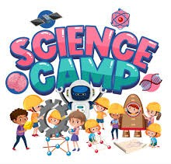
Camps run from 9:00am-4:00pm Early drop off & late pick up could be available as an extra charge

July 7th - 11th
^{Science camp}

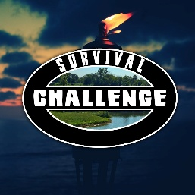
This camp is perfect for curious minds! Campers will become mini scientists for the week while we explore scientific facts, different scientific concepts, crafts, experiments, and more!

July 14th – 18th
Survival Challenge Camp
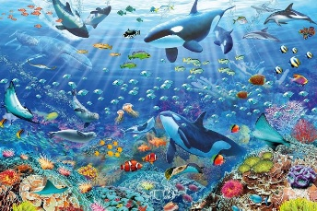
Inspired by Survival shows, this theme encourages leadership, teamwork, and problem-solving skills, Campers will get the chance to do scavenger hunts, build shelters, teamwork games, trivia and more fun!
July 21st - 25th
Underwater world

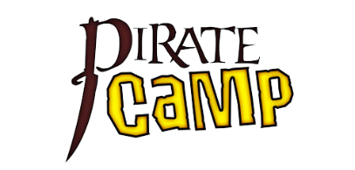
Come dive into the depths of the oceans with us! Campers will get the change to dive into the mysterious oceans around our planet. Campers will learn facts about our oceans, learn about marine life, create underwater crafts, water activities and more! Join us for our underwater fun!
August 11th - 15th
Pirate camp

Come join us on a pirate adventure! During the week campers will embark on a journey finding hidden treasure, creating pirate flags, learn pirate words, and sailing in races around the gym! Come sail, learn, and have fun!

August 18th - 22nd
Animal Kingdom


Perfect for any animal lover, this allows campers to explore animals native to Canada and around the world! This week campers will get the chance to craft different animals, learn about animal habitats, playing charades, animal races and more! Come join our wild animal adventures!
August 25th- 29th
Super summer wrap up
Summer fun creates memories for a lifetime. Your child will celebrate the friends they made and the good times they shared as the summer wraps up. Campers can reflect on the activities they have done throughout the summer.
Campers will need to bring: lunch, 2 snacks, water bottle, socks, sunblock, bug spray, good shoes for walking, swimsuit and towel
Full Day Camp is 5 years + ½ week camps are 4+

